JOB RECOMMENDATION SYSTEM

ADITYA ADHIKARI

TEXAS COLLEGE OF MANAGEMENT & IT



DEPARTMENT OF INFORMATION TECHNOLOGY

LINCOLN UNIVERSITY COLLEGE

FEBRUARY 6th, 2020

# Abstract

With increasing population and immerging technology, finding job have been difficult without searching through internet. Due to over population finding the suitable job in a short time that match our criteria is becoming very difficult because for one job vacancy many job seekers apply for the job. To reduce time and energy in finding job from online, the job recommendation system is very productive. This recommendation system is for effective online job hunting. In this project, both user-based and item-based collaborative filtering algorithm is used to choose a better performed one. A job seeker always spends hours to find useful ones, these recommended results can achieve higher score of precision and relevant result which makes user very satisfied.

# Acknowledgement

I would like to express my sincere gratitude to LU and TCMIT for giving me this opportunity to do this project. Many thanks go to project supervisor and project mentor, who have invested their full effort in guiding me in achieving the goal of the project. Last but not least I would like to thank all my dear friend, college team member and family for supporting me to do this wonderful project.

# Table of Content

Abstract i

Acknowledgement ii

Table of Content iii

Table of Figure v

List of abbreviation vi

CHAPTER 1: INTRODUCTION 1

1.1 Introduction 1

1.2 Background 1

1.3 Objective 2

1.4 Scope 2

1.5 Limitation 2

CHAPTER 2: LITERATURE REVIEW 3

2.1 Literature Review 3

2.2 Related work 4

Chapter 3: REQUIREMENT ANALYSIS AND FEASIBILITY STUDY 5

3.1 Requirement Analysis 5

3.2 Feasibility study 5

3.2.1 Technical Feasibility 5

3.2.2 Economical Feasibility 5

3.2.3 Operational feasibility 5

CHAPTER 4: ANALYSIS AND COMPARISON 6

4.1 Analysis 6

4.2 Comparison 6

Traditional way 6

Proposed system 6

4.3 Test Case & Result 7

4.4 Gantt chart 8

4.5 UI screenshots 9

4.6 Database Layout 10

CHAPTER 5: SYSTEM DESIGN 11

5.1 Use Case Diagram 11

CHAPTER 6: CONCLUSION 13

6.1 Conclusion 13

6.2 Future reference 13

References 14

Bibliography 15

# Table of Figure

Figure 1.Related work 4

Figure 2.Initial Gantt Chart 7

Figure 3. Revised Gantt Chart 7

Figure 4. UI Screenshot 1 8

Figure 5. UI Screenshot2 8

Figure 6.Database Layout 9

Figure 7.Client server architecture 10

Figure 8. Use case diagram 11

## List of abbreviation

JRS Job Recommendation System

HTML HyperText Markup Language

CSS Cascading Style Sheet

JS Java Script

DFD Data Flow Diagram

ER Entity Relationship

# CHAPTER 1: INTRODUCTION

## Introduction

Online job website or portal are the modern recruitment industry which shows us many jobs that are vacant. With millions of job seeker browsing through job postings every day, the need for accurate, effective, meaningful, and transparent job recommendations is needed more than ever.

Job websites is just used for display recruitment information to website viewers. Candidate have to retrieve all the information to find jobs they want to apply from different websites. The whole procedure is too long, slow and inefficient. By creating an easy job recommendation system where everyone will have a fair and square chance. This saves a lot of productive time and money on both the company hiring process as well as the job seeker’s side.

## 1.2 Background

Job recommendation system is a web app which deals with job provider and job seeker. Internet is very much essential for joining job provider and job seeker. According to Wikipedia, a web app “is an application that is accessed via a web browser over a network such as the Internet”. Some popular examples of web apps are Facebook, LinkedIn, Quora, Google, Twitter, Wikipedia, eBay etc. Web app can run in any browser and can be accessed through any devices that is connected to the internet.

Web app is very much popular and is used by everyone who uses internet. Knowing or unknowingly people are using web apps to make their life easier. Users do not need to install any specific software on their computer in order to access this web app, they just need web browser and internet. Web apps process our input data and provide us with required information.

For developing this web app first prototype is selected which helps in step by step developing of the project. For front-end Django/HTML/CSS is used and for back-end Python and MySQL database is used which will make the project very lifelike.

Job recommendation system suggest the job based on category that user has searched based on context, similarity, location etc.

## 1.3 Objective

* To build a highly personalized job recommendation system which suggests specific jobs from a set of job postings to users based on their skill set.
* To provide optimal solution for job seeker in a short time.

## 1.4 Scope

This job recommendation system is a web application suitable for all job seeking and job providing companies. Job seeker should first search the job then app can recommend the job according to the search and their skill. Job provider should send the job to the admin of the website so that their job vacancy can be posted in the app. This application is very easy and simple to understand so user want to access this web app.

## 1.5 Limitation

* User must know English language.
* Internet is required.

# CHAPTER 2: LITERATURE REVIEW

## 2.1 Literature Review

Job Recommendation work resides in the domain of online recommender systems, which are widely adopted across many web applications, e.g., movie recommendations, e-commerce item recommendations, job recommendations and so forth, where authors mainly concentrate on the relevance retrieval and ranking aspects of the recommendation system. There is insightful research and modeling of the hiring processes within job marketplaces. Such research includes work related to estimation of employee reputation for optimal hiring decisions, as well as work related to ranking and relevance aspects of job matching in labor marketplaces. There has been work related to the theory of optimal hiring process, e.g., on the problem of finding the right hire for a job (the hiring problem), as well as on the classical secretary problem, where a growing company continuously interviews and decides whether to hire applicants. Authors of investigated job marketplace as a two-sided matching market using locally stable matching algorithms for solving the problem of finding a new job using social contacts. RS can be treated as one of the most efficient tools for business, aimed directly at increasing revenue and profitability as well as optimizing current product portfolio [1].

According to International Conference on Advances in Computing, Communications and Informatics (ICACCI) job recommender systems are desired to attain a high level of accuracy while making the predictions which are relevant to the customer, as it becomes a very tedious task to explore thousands of jobs, posted on the web, periodically. Although a lot of job recommender systems exist that uses different strategies, here efforts have been put to make the job recommendations on the basis of candidate's profile matching as well as preserving candidate's job behavior or preferences. Firstly, rules predicting the general preferences of the different user groups are mined. Then the job recommendations to the target candidate are made on the basis of content-based matching as well as candidate preferences, which are preserved either in the form of mined rules or obtained by candidate's own applied jobs history. Through this technique a significant level of accuracy has been achieved over other basic methods of job recommendations [2].

## 2.2 Related work

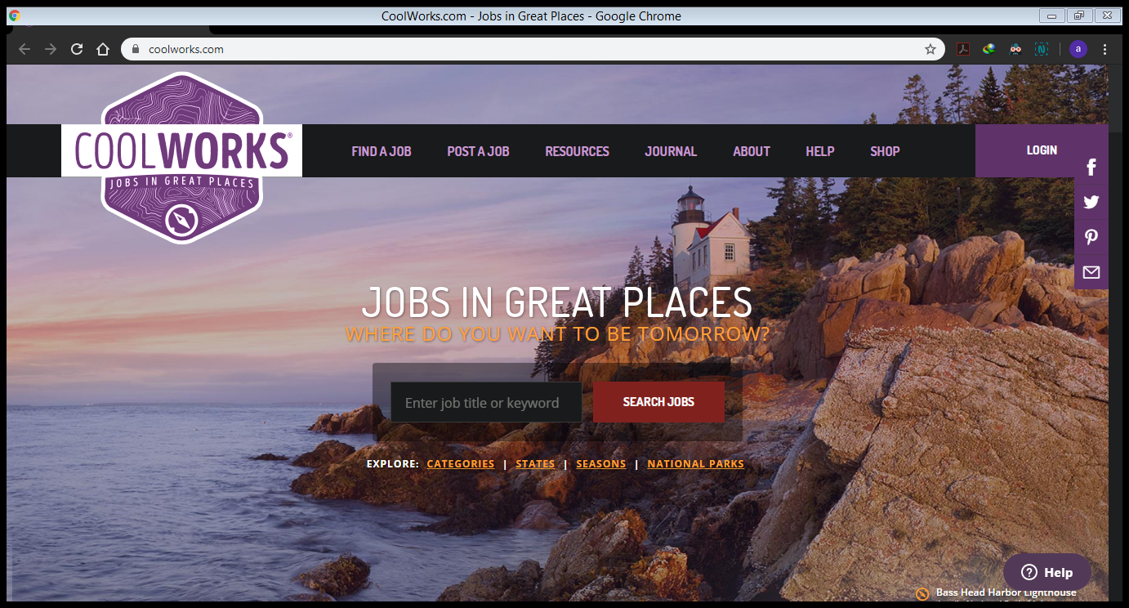

Figure .Related work

Cool Works is the best place for outdoor enthusiasts to find opportunities in exciting natural locations. The site is packed with summer, temporary, and full-time jobs and internships from employers such as ski areas, national parks, ranches, farms, and resorts. Cool Works includes international as well as domestic positions and fun search categories like, Jobs on Water, Jobs with Horses, Outdoor Adventures, and Lodge and Resort Jobs. Job seekers can search for temporary jobs by winter, spring, fall, or summer seasons.

# Chapter 3: REQUIREMENT ANALYSIS AND FEASIBILITY STUDY

# 3.1 Requirement Analysis

Requirements analysis involves all the tasks that are conducted to identify the needs of different stakeholders. Therefore requirements analysis means to analyze, document, validate and manage software or system requirements. Software requirement can be functional or non-functional.

## 3.2 Feasibility study

The main purpose of feasibility analysis is to check the economic viability of the proposed system. The result of the feasibility study will indicate whether to proceed with the proposed system or not. If the results of the feasibility study are positive, then we can proceed to develop a system otherwise project should not be pursued.

## 3.2.1 Technical Feasibility

This system will be developed using Django. As we require some time to learn all these technologies. All these technologies are easy to learn and can develop system very rapidly. After developing and deploying the system, any user can view this site on the Internet.

## 3.2.2 Economical Feasibility

Proposed System requires development tools and software such as Django, python and PyCharm (Community version) which are free of cost and available on internet. For developing proposed system, we need various resources such as computers systems, internet connection for e-help, recommended disk space, and memory speed for program to run.

## 3.2.3 Operational feasibility

Users of the system will the registered user of the website. To search user should have only basic knowledge of computer and Internet which is not a big issue. Basic training is required for other users to handle and manage the information.

# CHAPTER 4: ANALYSIS AND COMPARISON

## 4.1 Analysis

Job recommendation usually have system has: job name, job place, job time – part time / full time, job salary, job company, job categories like for it, bank, hospital etc.

Glassdoor is a job search website promotes itself as giving job seekers insights into a company’s work environment, interview processes, salaries and benefits.

Monster is massive job site, which launched in 1994, was one of the first commercial websites. It also provides networking boards, company profiles, a resume review service and a mobile app.

## 4.2 Comparison

## Traditional way

* People should wait in line.
* Nepotism is done.
* Takes long time.

## Proposed system

* Result is instantaneous.
* All have equal opportunity.
* Easy to use.

## 4.3 Test Case & Result

|  |  |  |
| --- | --- | --- |
| Test Cases | Objectives | Result |
| 1 | To check whether the username and password are stored in the database or not. | Ongoing |
| 2 | To check whether the button in signup and login page are working properly or not. | It is Functional. |
| 3 | To check whether the buttons in home page directing to another page or not. | It is Functional. |
| 4 | To check whether the photos are displayed if photos are inserted. | They are functional. |
| 5 | Database | Ongoing |

## 4.4 Gantt chart

Figure .Initial Gantt Chart



Figure . Revised Gantt Chart

## 4.5 UI screenshots

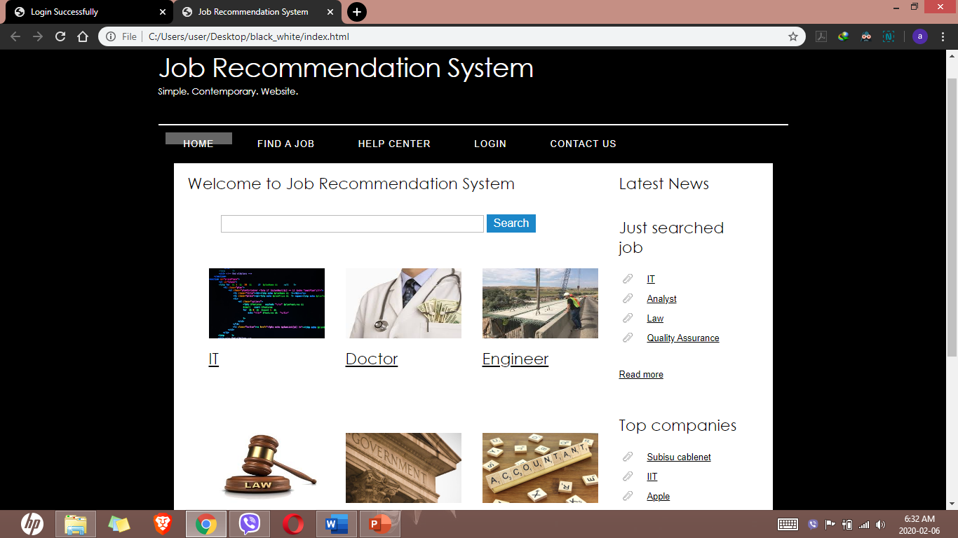

Figure . UI Screenshot 1

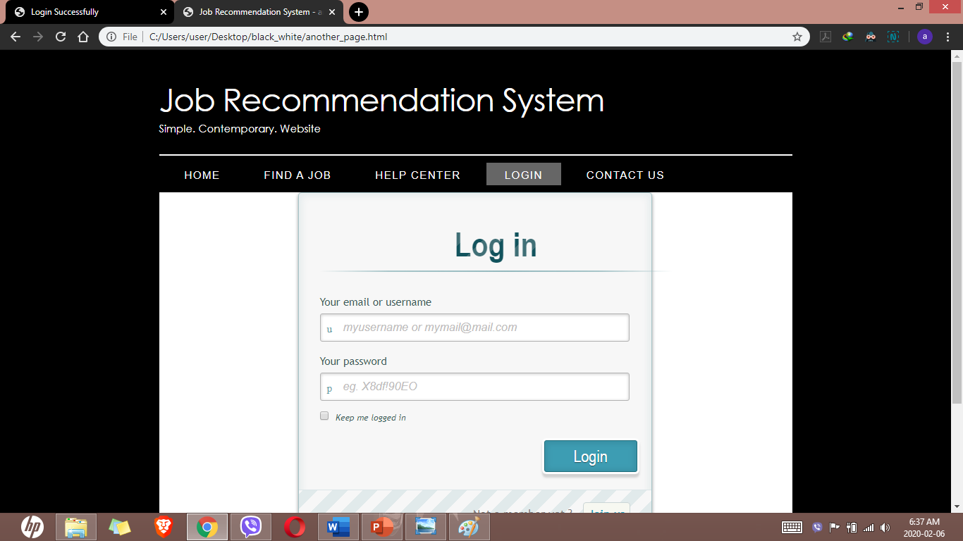

Figure . UI Screenshot2

## 4.6 Database Layout

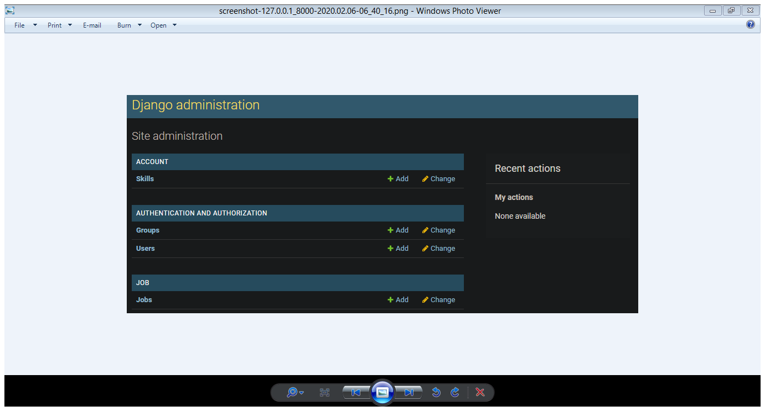

Figure .Database Layout

# CHAPTER 5: SYSTEM DESIGN

In system design there will be many things about the design of the system like use case diagram,DFD,ER diagram ,schema diagram.

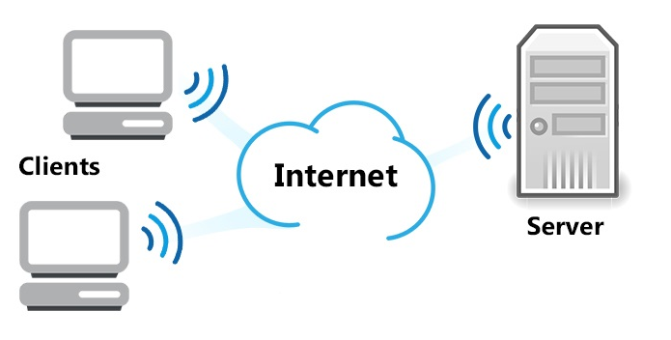

Figure .Client server architecture

Client is used for sending the request to the server and server gives the reply to the client.

## 5.1 Use Case Diagram

Use case diagram is used for capturing the dynamic nature of the system. It consists of use cases,actors and their relationships.use case diagram is used at high level design to capture the requirement of a system.

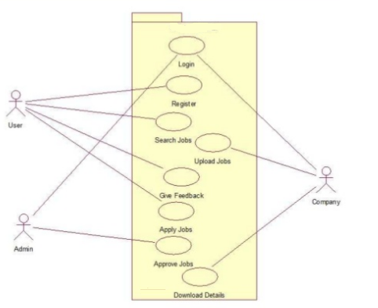

Figure . Use case diagram

# CHAPTER 6: CONCLUSION

## 6.1 Conclusion

Recommender system technologies have gained considerable popularity in online domains due to its effectiveness in creating commercial and social value. This project will be developed to make effective recommendation system for job finder and provider. This system increases the number of qualified applications that are made and reduce the amount of time it takes to apply for a job.

## 6.2 Future reference

Besides making this system very well functioned. In future there might be

* Chat bot in this system.
* Mobile app can be made.

# References

1. ijcat. 2019. Employment Recommendation System using Matching, Collaborative Filtering and Content Based Recommendation. [ONLINE] Available at: http://ijcat.com/archieve/volume7/issue6/ijcatr07061003.pdf. [Accessed 7 December 2019].

2. Semantic scholar. 2019. Applying data mining techniques in job recommender system for considering candidate job preferences. [ONLINE] Available at: https://www.semanticscholar.org/paper/Applying-data-mining-techniques-in-job-recommender-Gupta-Garg/97325a06de27b59c431a37b03c88f33e3a789f31. [Accessed 7 December 2019].

# Bibliography

* Flecke, L. K. (2015). Utilizing Facebook, LinkedIn and Xing as assistance tools for recruiters in the selection of job candidates based on the person-job fit.
* Kasper, K. (2015). Half of all job seekers aren't in it for the long haul, Jobvite job seeker nation study shows. Retrieved from: http://www.jobvite.com/pressreleases/2015/half-job-seekers-arent-long-hauljobvite-job-seeker-nation-study-shows/, 09-09-2015.
* International Research Journal of Engineering and Technology (IRJET) e-ISSN: 2395 -0056 Volume: 04 Issue: 05 | May -2017 www.irjet.net p-ISSN: 2395-0072
* International Journal of Computer Applications Technology and Research Volume 7–Issue 6, 215-220, 2018, ISSN: -2319-8656 Employment Recommendation System using Matching, Collaborative Filtering and Content Based Recommendation